COUNCIL ASSESSMENT REPORT
HUNTER AND CENTRAL COAST REGIONAL PLANNING PANEL

PANEL REFERENCE & DA NUMBER | PPSHCC-48  DA/872/2020
PROPOSAL | Recreation facility (major) – basketball facility  - 10 full-size basketball courts, including one show court seating for 2200 spectators  - change rooms / amenities  - canteen  - administration areas  - function room  - storage  - 355 car parking spaces (comprising 258 asphalt and 97 overflow spaces) and bus parking  - landscaping  - stormwater system including detention basin  - earthworks  - vegetation removal to facilitate access to Waratah Avenue  - line marking, signage, and other works within the existing road reserve to accommodate for traffic impact upgrades.
ADDRESS | 62 Hillsborough Road, Hillsborough (Lot 12 DP 879281)  62A Hillsborough Road, Hillsborough (Lot 11 DP 879281)  109 Waratah Avenue, Charlestown (Lot 6 DP 9594)  117 Waratah Avenue, Charlestown (Lots 7 and 8 DP 9594)
APPLICANT | Basketball Association of Newcastle c/- Catalyst Project Consulting
OWNER | Lake Macquarie City Council
DA LODGEMENT DATE | 19 June 2020
APPLICATION TYPE | Development application
REGIONALLY SIGNIFICANT CRITERIA | Schedule 6 – clause 3 of the Planning Systems SEPP  Council related development over $5 million
CIV | $19,888,965 (excluding GST)
CLAUSE 4.6 REQUESTS | Clause 4.3 Height of buildings
KEY SEPP/LEP | State Environmental Planning Policy (Resilience and Hazards) 2021  State Environmental Planning Policy (Planning Systems) 2021  State Environmental Planning Policy (Transport and Infrastructure) 2021  State Environmental Planning Policy (Biodiversity and Conservation) 2021  Lake Macquarie Local Environmental Plan 2014  Lake Macquarie Development Control Plan 2014
AGENCY REFERRALS & CONCURRENCE | Subsidence Advisory NSW  NSW Rural Fire Service  Natural Resource Access Regulator  Transport for NSW  Ausgrid  NSW Police
TOTAL & UNIQUE SUBMISSIONS  KEY ISSUES IN SUBMISSIONS | Notified:  - 24 June 2020 – 15 July 2020  - 13 January 2021 – 5 February 2021  - 1 March – 22 March 2022  Council had received 241 unique objections comprising:  - 234 objections  - 6 submissions in support  - 1 petition (against)  Key matters raised include:  - traffic impacts to the state and local road network  - insufficient information regarding event traffic management  - acoustic impacts  - ecology impacts  - bushfire outcomes  - social impacts
PREVIOUS BRIEFINGS | - 18 August 2020 (briefing)  - 17 March 2021 (briefing)  - 24 June 2021 (briefing and public briefing)  - 26 July 2021 (briefing)  - 10 February 2022 (briefing)
RECOMMENDATION | Approval – deferred commencement
DRAFT CONDITIONS TO APPLICANT | Yes
ATTACHMENTS | Attachment A: Draft conditions of consent
SCHEDULED MEETING DATE | 5 May 2022
PREPARED BY | Amy Regado, Section Manager Development
DATE OF REPORT | 28 April 2022

EXECUTIVE SUMMARY
Consent is sought for a recreation facility (major) comprising a basketball facility and associated works, at 62 and 62A Hillsborough Road, Hillsborough, and 109 and 117 Waratah Avenue, Charlestown.
The application is referred to the Hunter and Central Coast Regional Planning Panel as the application is Council related development over $5 million.
Five briefings have been held with the Hunter and Central Coast Regional Planning Panel.
The application was exhibited on three occasions and 241 submissions were received. Six submissions support the development, and 234 submissions, including one petition object to the development.
General terms of approval have been provided by Subsidence Advisory NSW and the Natural Resources Access Regulator.
Ausgrid confirmed the development is clear of electrical infrastructure.
Advisory conditions of consent have been provided by the NSW Rural Fire Service.
Transport for NSW provided advisory comments which have been considered as part of the assessment.
There were no concurrence requirements from agencies for the proposal.
The development has been assessed to be compliant with applicable State, Regional, and Local Environmental Planning Instruments and Policies, including:
- Environmental Planning and Assessment Act 1979
- Environmental Planning and Assessment Regulation 2000
- State Environmental Planning Policy (Biodiversity and Conservation) 2021
- State Environmental Planning Policy (Planning Systems) 2021
- State Environmental Planning Policy (Resilience and Hazards) 2021
- State Environmental Planning Policy (Transport and Infrastructure) 2021
- Lake Macquarie Local Environmental Plan 2014
- Lake Macquarie Development Control Plan 2014
The proposal is consistent with the various provisions of the planning controls including:
- Traffic impact associated with the development is acceptable, noting measures have been proposed to address peak impacts and impacts associated with events.
- The development does not adversely impact any ecological features/attributes of the site, including flora and fauna.
- The development achieves bushfire requirements.
- The development achieves appropriate acoustic privacy outcomes, particularly to nearby residential receivers.
- The development includes a building height variation which is considered appropriate for its location and be high-quality urban form.
- The development achieves appropriate built form outcomes.
- The development is consistent with the zone objectives.
Following a detailed assessment of the proposal, the development is considered in the public interest and worthy of approval subject to conditions contained in Attachment A.

- THE SITE AND LOCALITY
The site comprises four lots having frontage to Waratah Avenue, and an unnamed access road that links to the southbound on-ramp of the Newcastle Inner City Bypass (NICB).
The site comprises an area of approximately 6.7 hectares with a large open and previously cleared area providing for the footprint of the proposed development. An existing dwelling house is located near the eastern boundary of the site, fronting Waratah Avenue, near the intersection with Brett Street. This dwelling is proposed to be retained.
Native vegetation is located in the southern and eastern portions of the site. Winding Creek traverses the southern area of the site, outside the development footprint. An unnamed first order watercourse traverses the site in a north south direction toward the eastern boundary of the site. NICB is adjacent to the western boundary of the site. Hillsborough Public School and Glendon Special School are located to the north and east of the development site. Low-density residential development is located east of the site.
The site is zoned RE1 Public Recreation for the northern and part of the eastern section of the site, and C2 Environmental Conservation for the southern and remaining eastern portions, as shown in Figure 1.
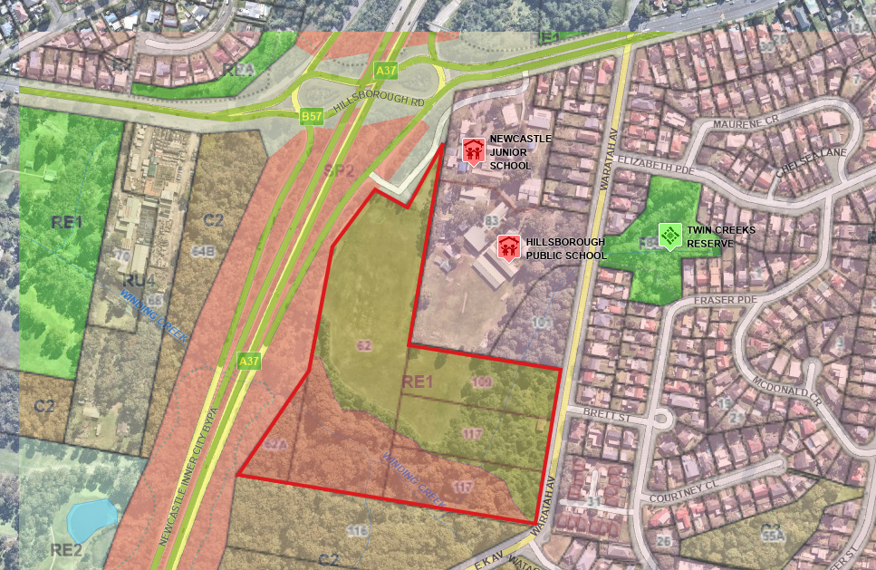
Figure 1: Location map including zoning overlay

- THE PROPOSAL AND BACKGROUND
  - The proposal
Consent is sought for a recreation facility (major) comprising a basketball facility and associated works. Specifically, the development involves:
- 10 full-size basketball courts, including one show court seating for 2200 spectators
- change rooms/amenities
- canteen
- administration areas
- function room
- storage
- 355 car parking spaces (comprising 258 asphalt and 97 overflow spaces) and bus parking
- landscaping
- stormwater system including detention basin
- earthworks
- vegetation removal to facilitate access to Waratah Avenue
- line marking, signage, and other works within the existing road reserve to accommodate for traffic impact upgrades.
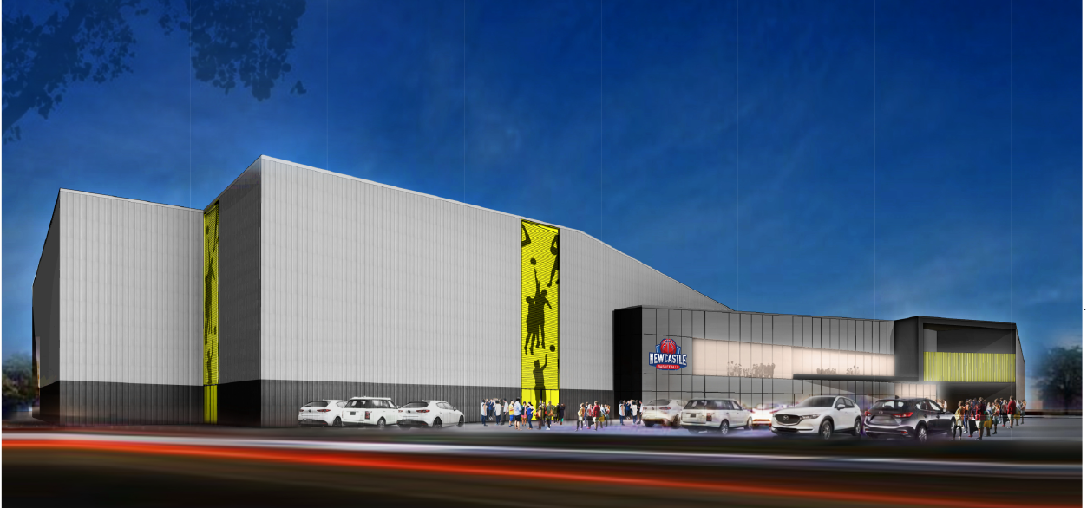
Figure 2: Perspective of southern elevation
The facility is intended to be a regional basketball facility and provide a new base for Newcastle Basketball, who are currently located at Broadmeadow.
The application specified signage to be included in the development, however, limited detail has been provided to enable assessment of this element. Accordingly, no consideration of signage has been undertaken, and conditions of consent are proposed requiring separate development consent for any signage that is not exempt development.
The development to be considered reflects modified and scaled down version of the facility originally proposed. In particular, the stadium capacity has been reduced from 4000 seats to 2500 seats and the floor plan of the development has reduced the capacity of the facility while the stadium court (or show court) is in operation. That is, there are nine courts available when the show court is operable with ten courts only available when the show court is not operational, as shown in Figures 3 and 4 below.
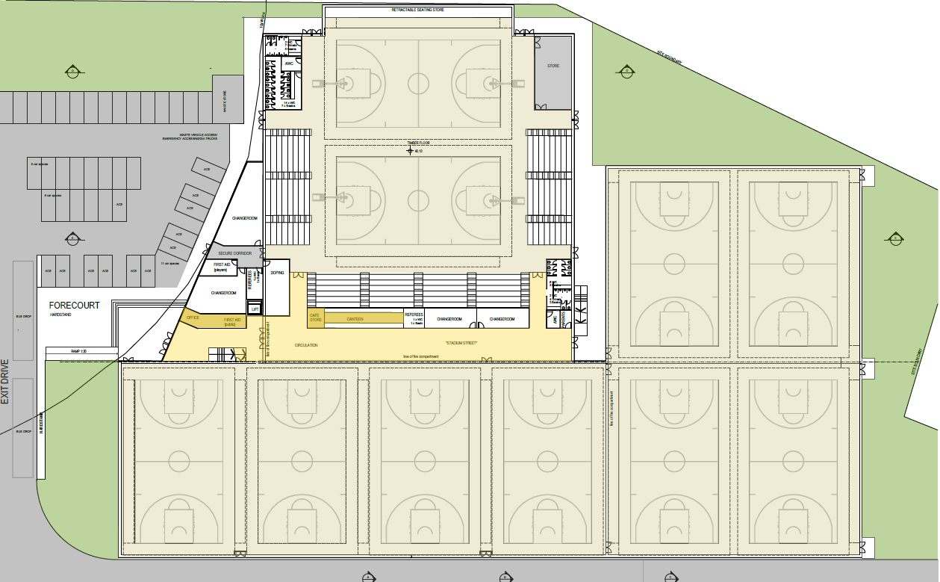
Figure 3: Floor plan with ten court layout; no stadium court
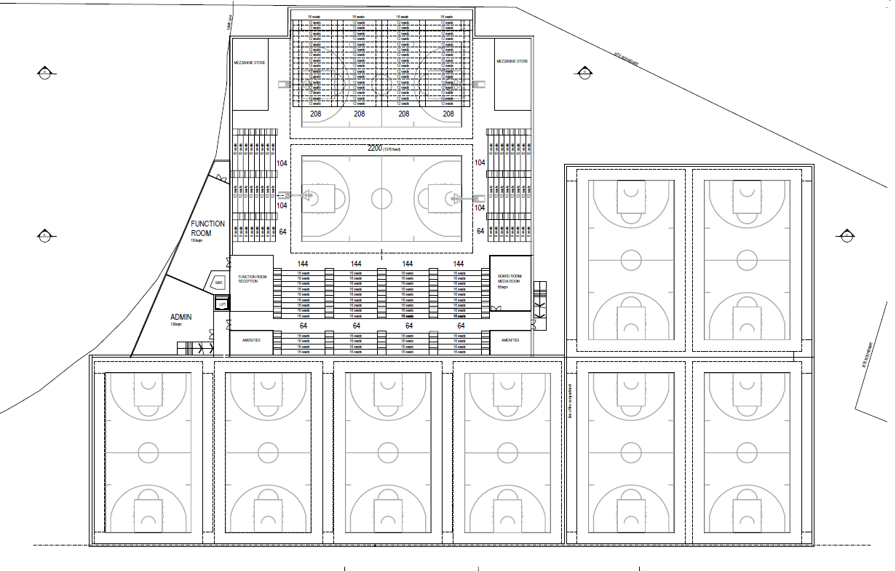
Figure 4: Floor plan with stadium court operation, showing total of nine courts

  - Background
A pre-lodgement meeting was held before the lodgement of the application in April 2020 where the following key matters were discussed:
- bushfire
- ecology
- building height
- vehicular access
- parking rates
- flooding (confirmation the site is not flood prone)
- stormwater
The development application was lodged on 19 June 2020. A chronology of the development application since lodgement is outlined in Table 1.

Table 1: Chronology of the DA
Date | Event
22 June 2020 | Lodgement of application
14 June – 15 July 2020 | Notification of the application
June/July 2020 | DA referred to internal officers and external agencies
31 July 2020 | Request for information (RFI) issued to applicant
18 August 2020 | RPP briefing
January 2021 | Amended plans and documentation submitted by applicant.
13 January – 5 February 2021 | Re-notification of application
January/February 2021 | DA referred to internal officers and external agencies
4 March 2021 | RFI issued to applicant
17 March 2021 | RPP briefing
24 June 2021 | RPP briefing and public briefing
26 July 2021 | RPP briefing
10 February 2022 | RPP briefing
September 2021  February 2022 | Amended plans and documentation submitted by applicant.  Confirmation of continued assessment of the application
1 March – 22 March 2022 | Re-notification of application
March/April 2022 | DA referred to internal officers and external agencies

- STATUTORY CONSIDERATIONS
  - Section 4.15(1)(a)(i) - Provisions of Environmental Planning Instruments
The following Environmental Planning Instruments are relevant to this application:
- State Environmental Planning Policy (Biodiversity and Conservation) 2021
- State Environmental Planning Policy (Planning Systems) 2021
- State Environmental Planning Policy (Resilience and Hazards) 2021
- State Environmental Planning Policy (Transport and Infrastructure) 2021
- Lake Macquarie Local Environmental Plan 2014
A summary of the key matters for consideration arising from these State Environmental Planning Policies is outlined in Table 2 and considered in more detail below.

Table 2: Summary of applicable State Environmental Planning Policies
EPI | Matters for consideration | Comply (Y/N)
Biodiversity and Conservation SEPP | Chapter 3 – Koala habitat protection 2020 applies to the application.  The BDAR has included an assessment of koalas and their habitats in accordance with this SEPP and concluded habitat on-site is highly suitable for this species however, there is limited evidence and the site is not considered to be core koala habitat.  Council’s Ecologist has considered the proposal and is satisfied the proposal is acceptable. | Y
 | Chapter 6 – Bushland in urban areas applies to the application.  The removal of the vegetation is considered to be acceptable as the extent of clearing has been minimised, located to avoid higher value vegetation, and is essential to provide a second vehicle access for the development. | Y
Planning Systems SEPP | Chapter 2 – State and regional development applies to the application.  The application is Council related development over $5 million and is regionally significant development in accordance with Part 2.4 and Schedule 6 – clause 3. | Y
Resilience and Hazards SEPP | Chapter 4 – Remediation of land applies to the application.  A Preliminary Site Investigation was undertaken and no indication of gross contamination which would constrain the development of the site for its proposed land use, and confirmed the site is suitable for the intended use without remediation. | Y
Transport and Infrastructure SEPP | Chapter 2 - clause 2.48 - Determination of development applications—other development) – electricity transmission.  The application was referred to Ausgrid who advised the development is clear of electrical infrastructure. | Y
 | Chapter 2 - clause 2.118 – Development with frontage to classified road and clause 2.121 - Traffic Generating Development.  The application was referred to TfNSW who raised concerns over afternoon weekday peak vehicle impact, and traffic impact from events.  Through the implementation of traffic controls measures and an event management plan, it is considered the development can operate, and be managed to ensure the efficient and ongoing operation of the NICB, classified roads and the local road network as detailed above. | Y
 | Chapter 2 – clause 2.137 stormwater management systems – development permitted with consent  The development includes a spillway associated with the stormwater detention basin on the southern side of the development that extends into the portion of the site zoned C2 Environmental Conservation. The SEPP permits development for the purposes of a stormwater management system to be carried out on any land. | Y

State Environmental Planning Policy (Biodiversity and Conservation) 2021
The site has an area of over one\ hectare, and is subject to chapter 3 – Koala habitat protection 2020 applies to the application. Lake Macquarie City Council does not have a koala plan of management.
A Biodiversity Development Assessment Report (BDAR) has been submitted with the application which includes an assessment of koalas and their habitats in accordance with this SEPP. The report concluded habitat on-site is highly suitable for koalas however there is limited evidence of the presence and the site is not considered to be core koala habitat.
Council’s Ecologist has considered the proposal and BDAR and is satisfied the proposal is acceptable.

The site is zoned for RE1 Public Recreation and identified as bushland, in this regard chapter 6 – Bushland in urban areas applies to the application.
The application proposes removal of approximately 0.33 hectares of remnant native vegetation, which relates to the bridged vehicle access from Waratah Avenue. No further clearing is required within the main building footprint to enable the development, inclusive of bushfire asset protection zones (APZs).
As per the SEPP, consent is sought for these works. The removal of the vegetation is considered acceptable as the extent of clearing has been minimised, development located to avoid higher value vegetation, and the provision of a second vehicle access essential for the development.

State Environmental Planning Policy (Planning Systems) 2021
The application is regionally significant development under Part 2.4 Regionally significant development and Schedule 6 – clause 3 of the SEPP as Lake Macquarie Council owns the land and the capital investment value of the development exceeding $5 million.
Accordingly, the Hunter and Central Coast Regional Planning Panel (RPP) is the consent authority for the application.

State Environmental Planning Policy (Resilience and Hazards) 2021
Under clause 4.6 of the SEPP, a consent authority must not consent to the carrying out of any development on land unless it has considered whether the land is contaminated, and if the land is contaminated, it is satisfied the land is suitable in its contaminated state (or will be suitable after remediation) for the purpose for which the development is proposed to be carried out.
The lots comprising the development site consist of vacant land. Council’s records do not identify any historic land uses or notices in relation to the land being contaminated.
A preliminary site investigation was undertaken. The preliminary site investigation determined no indication of gross contamination which would constrain the development of the site for its proposed land use, and confirmed the site is suitable for the intended use without remediation.

State Environmental Planning Policy (Transport and Infrastructure) 2021
The application was referred to Ausgrid under clause 2.48 of the SEPP. Ausgrid advised the development is clear of electrical infrastructure, as such there is no objection to the development.

The application was referred to Transport for NSW (TfNSW) under clause 2.118 and 2.121 as the site has frontage to a classified road (the NICB) and the development triggers traffic-generating development as the car park associated with the development has a capacity greater than 50 vehicles with access within 90m of a classified road and will also generate greater than 50 vehicles per hour during peak usage.
TfNSW identified several concerns regarding the traffic impact of the development, particularly concerning the afternoon weekday peak vehicle impact, and traffic impact from events. Through the implementation of traffic controls measures and an event management plan, it is considered the development can operate, and be managed to ensure the efficient and ongoing operation of the NICB and local road network as detailed above.
For detailed consideration of this matter, refer to assessment under Key Matters.

The development includes a spillway associated the stormwater detention basin on the southern side of the development that extends into the portion of the site zoned C2 Environmental Conservation. Clause 2.137 permits development for the purposes of a stormwater management system to be carried out on any land.

Lake Macquarie Local Environmental Plan 2014
The relevant local environmental plan applying to the site is the Lake Macquarie Local Environmental Plan 2014 (LMLEP 2014).
The site is zoned RE1 Public Recreation and C2 Environmental Conservation. Works, including APZs, are located in the RE1 zone.
The development land use is defined as recreation facility (major) under LMLEP 2014 and is permissible in the RE1 Public Recreation zoning, subject to development consent.
The development includes a spillway associated the stormwater detention basin that extends into the portion of the site zoned C2 Environmental Conservation. These works are permitted with consent under the Transport and Infrastructure SEPP.
The proposal is considered consistent with the zone objectives as follows:
- The development provides the use of the land for recreational purposes.
- The development protects the natural environment and environmental qualities of land.
The LEP also contains controls relating to development standards, miscellaneous provisions, and local provisions. The controls relevant to the proposal are considered in Table 3 below.

Table 3: Consideration of the LEP controls
Control | Requirement | Proposal | Comply
Height of buildings  (cl 4.3) | 8.5m (RE1 zone) | 13.7m, which equates to a 5.2m or 61 percent variation.  Refer to discussion under Key Matters. | N  Supported by clause 4.6 variation, considered acceptable
Heritage conversation  (cl 5.10) | Consideration must be given to the effect of the development on heritage significance of Aboriginal objects or places.  Notification must be given to local Aboriginal communities for at least 28 days. | An Aboriginal Heritage Due Diligence Assessment was submitted identifying an area of potential archaeological deposit, which would require archaeological subsurface investigation to be undertaken, should it be impacted by any works. Recommendations were contained in the report and conditions of consent are proposed to achieve this outcome.  The application was referred to the local Aboriginal community groups; no submissions were received. | Y
Earthworks  (cl 7.2) | Consideration must be given to:  - impacts on drainage patterns, soil stability, or environmentally sensitive areas.  - the effect on the development, including on amenity of adjoining properties.  - the source and quality of the fill to be excavated.  - the likelihood of disturbing relics  - measures to avoid, minimise or mitigate impacts. | The application proposes excavation up to a maximum of 3m of cut and 2m of fill across the building footprint.  Batters have been used throughout the site, however, retaining walls are proposed along the boundary of the school site which generally has heights no higher than 1.2 metres.  Appropriate stormwater management has been included to ensure the works do not have an impact on drainage patterns.  Council’s Development Engineer is satisfied with the proposed earthworks.  Conditions of consent can be imposed to ensure only quality fill is imported and earthworks works are undertaken appropriately. | Y
Essential services  (cl. 7.21) | Development consent must not be granted unless the consent authority is satisfied the following services are available to the development:  (a) the supply of water,  (b) the supply of electricity,  (c) the disposal and management of sewage,  (d) stormwater drainage or on-site conservation,  (e) suitable vehicular access. | The site has adequate availability of water, sewer, electricity, and telecommunications to service the development.  The development has incorporated appropriate stormwater management.  Suitable vehicle access is provided to the development. | Y
The proposal is considered generally consistent with the LEP.

  - Section 4.15 (1)(a)(ii) - Provisions of any proposed instruments
There are no proposed instruments that apply to the development.

  - Section 4.15(1)(a)(iii) - Provisions of any Development Control Plan
The Lake Macquarie Development Control Plan 2014 (LMDCP 2014) is relevant to the application. In particular, Part 6 Development in Recreation and Tourist Zones.
The controls relevant to the proposal are considered in Table 4 below.

Table 4: Consideration of DCP controls
Control | Discussion | Comply
Geotechnical | The footprint of the development is within a ‘Geo 5’ geotechnical zone (low risk zoning). Council’s Development Engineer confirms a slope stability analysis is not warranted. | Y
Stormwater | The development includes stormwater infrastructure that captures stormwater generated by the development and, through a series of pits and pipes and grass swales directs stormwater to Winding Creek in the south of the site. A detention basin is also included to capture overland flow and major storm events.  Stormwater from roof areas will be directed to rainwater tanks for re-use in toilets and landscaping areas in the development. Overflow will be directed to the detention basin.  Council’s Development Engineer considers the submitted stormwater management design satisfactory.  Existing stormwater infrastructure from Hillsborough Public School currently drains over the site and will be connected into the drainage system of the proposed stadium at the property boundary. There are currently no easements for drainage over the land. An easement is required to be registered over the property to ensure ongoing rights for drainage are maintained. This can be achieved through a condition of consent. | Y
Natural water systems | The stormwater management system is designed to have minimal impact on the water regime and water quality of Winding Creek. There will be some removal of riparian vegetation to accommodate the bridged vehicular access from Waratah Avenue. Works within this area will be managed under a controlled activity approval from the Natural Resources Access Regulator.  Council’s Environmental Systems – creeks and watercourses officer has reviewed and is supportive of the development. | Y
Bushfire | A bushfire report, including revisions, has been submitted with the application. The report identifies the development can achieve required bushfire protection measures.  NSW RFS has reviewed and is supportive of the development and provided recommended conditions of consent.  For detailed consideration of this matter, refer to assessment under Key Matters. | Y
Flora and fauna  Preservation of trees and vegetation | A BDAR was submitted with the application which outlines the proposed impacts of the development, including vegetation removal, and concludes the development is acceptable and meets the provisions of the relevant biodiversity legislation.  Council’s Ecologist has reviewed and is supportive of the development.  An arborist report has been submitted which recommends the removal of five trees located adjacent to the boundary on the adjoining school site. This is due to the earthworks and retaining required along the boundary. Owner’s consent has been provided from the Department of Education for this removal. Several other trees were identified as requiring sensitive construction methods. Conditions are proposed to ensure appropriate techniques are implemented to ensure retention.  For detailed consideration of this matter, refer to assessment under Key Matters. | Y
Social impact | Social impact has been addressed within the Statement of Environmental Effects and reviewed by Council’s Social Planner. The development is considered to provide an overwhelmingly positive social impact.  The new stadium will replace the existing aging facility at Broadmeadow and will ensure that the needs and expectations of the city and wider community can be met.  Furthermore, the facility will help promote healthy activities, encourage tourism through the staging of events, and provide a variety of community programs that will encourage children, families, seniors, people with a disability, and the socio-economically disadvantaged, to take part in activities carried out at the facility.  Local impacts such as traffic, parking, noise, and the like have been considered and are considered acceptable on balance. | Y
Economic impact | The development will have a positive economic contribution to the locality through the creation of jobs through the construction phase, as well as during operation. Additionally, the ability to host regional and national events will bring in people from outside the area, promoting tourism in the local area. | Y
Scenic values / Streetscape / building bulk / roofs | The site is located at the base of the Charlestown ridge and will not impact scenic values of the ridgeline.  There will be close up views of the development from the NICB on-ramp and potentially from the NICB itself as well as the adjacent school. Otherwise, the development is not readily visible from the street.  The road reserve flanking the NICB on-ramp is densely vegetated. This vegetation is not affected by the proposal and will provide an element of screening from this viewpoint. Views from the NICB will also be fleeting as motorists pass the site and will not dominate the landscape.  The development will impact the existing westerly outlook from the adjacent school. The design of the building has incorporated measures to mitigate the visual impact by including varied materials within the façade, including stenciled concrete panels.  No detrimental impacts to the existing streetscape are anticipated.  Roof plant is shown on the western portion of the roof and will be screened from view. | Y
Front setback | The site is irregular in shape with frontage to the NICB on-ramp and Waratah Avenue.  The development is most highly visible from the NICB on-ramp and therefore for the purposes of this assessment, this will be considered the front boundary. The development maintains a setback between 8 and 9m from the entry site boundary.  Buildings are well setback from Waratah Avenue.  Setback to the NICB on-ramp is 1.4m although this remains well setback from the carriageway and is separated from it by vegetation that will act to provide screening. The northwest corner of the development is built almost to the boundary. No adverse impacts are anticipated as a result as there is no adjoining development. | Y
Side and rear setback | The development is positioned a considerable distance from the southern boundary of the site and will not cause any adverse impacts.  A setback of 9.95m is proposed from the building to the eastern boundary adjoining the school. | Y
Solar access | The development achieves appropriate solar access outcomes, with limited impact on adjoining lands. Shadows cast by the development largely fall within the site. | Y
Energy efficiency | The development will be subject to compliance with the relevant provisions of Section J of the BCA. | Y
Landscaping and fencing | Landscaping documentation has been submitted with the application. However, it is noted a revised plan that reflects the most recent site layout changes has not been submitted.  Council’s Landscape Architect identified concerns with the proposed planting scheme based on the original site layout.  Appropriate landscaping outcomes are achievable for the site and development, and conditions of consent are proposed requiring revised landscaping documentation be submitted to Council for approval before the release of the construction certificate.  Palisade fencing will be installed around the perimeter of the site for security purposes. This is consistent with fencing of the neighbouring school and will not negatively affect the streetscape. | Y
Car parking design and provision | The design of the car park has been reviewed by Council’s Development Engineer who has identified further information is required to ensure car parking can achieve compliance with LMDCP 2014 and AS2890.  While this information could be submitted for assessment under the development application, adequate area exists within the development footprint to accommodate modifications to comply with the Australian Standard. Conditions of consent are proposed requiring this information prior to issue of the construction certificate. This will enable detailed review of the car parking layout to be undertaken. Where adjustments are required, sufficient car parking area exists in the overflow car parking area to provide more formed car parking spaces to account for any adjustments.  The DCP specifies a parking rate of 20 car parking spaces per court. The development includes 10 courts and therefore requires 200 car parking spaces be provided.  The development provides 258 formalised parking spaces, including 12 disabled parking spaces, plus 97 informal overflow parking spaces (total capacity 355).  Additionally, ten designated motorbike parking spaces are provided.  The proposed parking will cater for the normal operations of the facility.  Parking during events will be managed through an Events Traffic Management Plan. It is acknowledged a plan has been submitted with the application, however the plan is not sufficient to be adopted as a plan for future events. A condition of consent can be imposed requiring a more detailed and specific plan to be submitted for approval prior to the operation of the first event, with the plan to be a ‘living’ document that is updated based upon feedback/outcomes of events.  Bike parking can be accommodated adjacent to the building entry through conditions of consent. Change rooms/showers are provided within the development. | Y
Non-discriminatory access | An access audit was submitted with the application. The report outlines the development can meet relevant standards, with further detail to be provided as part of the construction certificate process.  Council’s Disability Access officer has reviewed and supported the recommendations of the report. The report is proposed to be included as an approved document with conditions of consent to specifically ensure required outcomes are achieved. | Y
Crime prevention | A Crime Risk Assessment was submitted with the application. This report outlines the development achieves or can achieve, through conditions of consent, crime prevention through environmental design (CPTED) principles through surveillance (lighting and CCTV), access control (gates and fencing), territorial reinforcement (signage), and space management (landscaping and maintenance).  Council’s Youth and Safety officer has reviewed and supported the recommendations of the report. The report is proposed to be included as an approved document with conditions of consent to ensure required outcomes are achieved. | Y
Operational waste management | The application proposes engagement of private contractors for all waste streams associated with the development.  A dedicated waste store is located at the southwestern corner of the building.  Conditions of consent are proposed to ensure waste servicing is contracted before operation of the development. | Y
Erosion and sediment | Conditions of consent are proposed to ensure appropriate erosion and sediment controls are implemented before, during, and post-construction. | Y
Noise and vibration | An acoustic assessment, including revisions, has been submitted with the application. The report identifies the development can achieve required acoustic outcomes.  Council’s Environmental Management officer has reviewed and is supportive of the development.  For detailed consideration of this matter, refer to assessment under Key Matters. | Y

The development is subject to payment of development contributions under clause 7.12 of the Environmental Planning and Assessment Act 1979. A condition of consent is proposed detailing the contribution amount and timing of payment.
  - Section 4.15(1)(a)(iiia) – Planning agreements under Section 7.4 of the EP&A Act
There have been no planning agreements entered into and there are no draft planning agreements being proposed for the site.

  - Section 4.15(1)(a)(iv) - Provisions of Regulations
Part 4 Division 1 of the Regulation contains matters that must be taken into consideration by a consent authority in determining a development application. No matters are relevant to the modification application.

  - Section 4.15(1)(b) - Likely impacts of development
The likely impacts of that development, including environmental impacts on both the natural and built environments, and social and economic impacts have been detailed throughout the assessment report.

  - Section 4.15(1)(c) - Suitability of the site
The development is suitable for the site, as detailed in this report.

  - Section 4.15(1)(d) - Public submissions
These submissions are considered in section 4.3 of this report.

  - Section 4.15(1)(e) - Public interest
The development achieves balanced and orderly outcomes, and is therefore considered to be in the broader public interest.

- REFERRALS AND SUBMISSIONS
  - Agency referrals and concurrence
The development application has been referred to agencies for comment and referral as required by the Environmental Planning and Assessment Act (EP&A Act) and outlined below in Table 5.
There are no outstanding issues arising from these concurrence and referral requirements subject to the imposition of the recommended conditions of consent being imposed.
Table 5: Concurrence and referrals to agencies
Agency | Concurrence /  referral trigger | Comments | Resolved
Concurrence (s4.13 of EP&A Act)
Nil
Integrated development (s4.46 of the EP&A Act)
NRAR | S91 – Water Management Act 2000  Water use approval, water management work approval, or activity approval under Part 3 of Chapter 3. | NRAR provided GTAs on 25 November 2020 and confirmed in March 2021 the amended plans did not affect the GTAs issued. | Y
SA NSW | S22 – Coal Mine Subsidence Compensation Act 2017  Alter or erect improvements within a mine subsidence district. | SA NSW provided GTAs to the amended plans on 5 April 2022. | Y
Referral / consultation agencies
TfNSW | Clause 2.118 – Development with frontage to a classified road  Clause 2.121 - Traffic Generating Development | The development was referred to TfNSW for advisory comment based upon the original design.  TfNSW raised concern about the traffic impact of the development. Through the implementation of traffic controls measures and an event management plan, the development can operate, and be managed to address TfNSW’s concerns. | Y
NSW RFS | 4.14 EP&A Act  Consultation and development consent—certain bush fire prone land | NSW RFS provided their recommended conditions based upon the amended plans on 13 April 2022. | Y
Ausgrid | Clause 2.48 - Determination of development applications—other development) – electricity transmission. | The original application was referred to Ausgrid under clause 2.48 of the Transport and Infrastructure SEPP. Ausgrid advised the development is clear of electrical infrastructure, as such there is no objection to the development. | Y
NSW Police | 4.15 EP&A Act  likely impacts of that development | No referral response was received during the assessment of the application. | Y
  - Council referrals
Referrals were received from various Council officers for technical review as outlined in Table 6.
Table 6: Consideration of Council referrals
Officer | Comments | Resolved
Traffic and transport | The officer reviewed the traffic impacts of the development, including TfNSW comments, and is satisfied the development is appropriate for the site subject to recommended conditions of consent. | Y
Development Engineer | The officer is generally supportive of the development.  The officer has recommended conditions of consent relating to stormwater management, car parking and road works. | Y
Flora and Fauna | Council’s Ecologist considered the development proposal, including APZs and specific BDAR and is satisfied the development is acceptable subject to conditions regarding:  - nest box installation,  - the retirement of biodiversity credits, and  - implementation of a vegetation and fauna management plan. | Y
Arborist | An arborist report has been submitted which recommends the removal of five trees and retention of several other trees.  Council’s Arborist prefers further detail to be submitted during the assessment, however, conditions are proposed to ensure appropriate techniques are implemented to ensure retention of the nominated trees. | Y
Environmental Systems – creeks and watercourses | The officer has reviewed and is supportive of the development, particularly acknowledging the development includes appropriate stormwater management, has minimised earthworks near the riparian zone, has maintained an appropriate setback to the creek, and will install appropriate erosion and sediment controls. | Y
Aboriginal heritage | An Aboriginal Heritage Due Diligence Assessment was submitted and identified an area of potential archaeological deposit, which would require archaeological subsurface investigation to be undertaken, should it be impacted by any works.  The application was referred to the local Aboriginal community groups; no submissions were received.  Council’s Heritage Planner is satisfied the proposal is acceptable subject to conditions regarding unexpected finds during construction and further investigation of the identified object. | Y
Erosion and sediment | The officer requested further documentation. However, it is considered the matters requested can be resolved within the proposed conditions of consent with construction certification documentation reflecting this additional detail. | Y
Landscape | Landscaping documentation has been submitted with the application. However, it is noted a revised plan reflecting the most recent site layout changes has not been submitted.  Council’s Landscape Architect identified concerns with the proposed planting scheme based on the original site layout.  Appropriate landscaping outcomes are achievable for the site and development, with conditions of consent recommended requiring revised landscaping documentation be submitted to Council for approval before the release of the construction certificate. | Y
Environmental Management | Revised acoustic documentation has been submitted with the application.  Council’s Environmental Management Officer is supportive of the development subject to conditions regarding compliance with acoustic reporting, implementation of noise limiting equipment, and implementation of a noise management plan. | Y
Social impact | Social impact has been addressed within the Statement of Environmental Effects.  Council’s Community Planning officer considers the development to provide an overwhelmingly positive social impact. | Y
Disability access | A revised access audit report was submitted with the application.  The officer reviewed the proposal and is satisfied with the report subject to the report being included in approved documents. | Y
CPTED | A revised CPTED report was submitted with the application.  The officer reviewed the application and is satisfied the report addresses CPTED within the development subject to conditions regarding additional best practice measures. | Y
Waste servicing | The officer requested further information regarding the waste servicing and streams of the development.  The application proposes engaging private contractors for all waste streams associated with the development, with a dedicated waste store located at the southwestern corner of the building.  Further information is not considered necessary with conditions of consent proposed to ensure waste servicing is implemented before the operation of the development. | Y
Health | The officer reviewed the application and is supportive of the development, subject to conditions of consent regarding fit-out of food handling areas. | Y
Building Surveyor | A BCA report has been submitted with the application. The officer reviewed the application and is satisfied with the report. | Y
Environmental Systems – sustainable buildings and transport | The officer requested further information regarding solar photovoltaic system, achievement of energy efficiency under the BCA, stormwater management, end of trip facilities, and EV charging spaces.  These matters are considered by other technical staff, or are not relevant to the planning merits of the development, or can be achieved by conditions of consent. | Y

  - Community consultation
The proposal was notified on three occasions in accordance with the Council’s Community Participation Plan:
- 24 June 2020 – 15 July 2020
- 13 January 2021 – 5 February 2021
- 1 March – 22 March 2022.
Notification was sent to adjoining properties, properties within the residential area east of the site (for second and third renotification), and those who provided submissions (for second and third renotification).
Council received 241 unique submissions over the three notification periods. A breakdown of the submissions is provided below:
- 234 objections
- 6 submissions in support
- 1 petition containing 48 signatures (against the proposal)
- 123 total number of submitters (noting a number of submitters provided several submissions)
- 10 submissions received during the first notification
- 23 submissions received between the first and second notification
- 69 submissions received during the second notification
- 83 submissions received between the second and third notification, which included the RPP public briefing
- 49 submissions received during the third notification
- 8 submissions received following third notification.
The issues raised in these submissions are considered in Table 7.
Table 7: Community submissions
Issue | Council comments
General objection / site is not suitable | The development has been assessed as compliant with applicable legislation. The site is suitable, subject to conditions of consent. Further detailed assessment of the site and its constraints is provided through this assessment report.
Traffic impact to state road network.  This includes:  - response from TfNSW  - time based restrictions for access to the site on weekdays not suitable  - removal of parking lane along Hillsborough Road  - bus turning from Hillsborough Road into Waratah Avenue  - increased traffic to state road network. | Traffic impact associated with the development is acceptable, noting measures have been proposed to address peak impacts and impacts associated with events.  Further detailed discussion is provided under Key Matters.
Traffic impact to local road network  This includes:  - increase in traffic from development (non-events)  - removal of on-street car parking to cater for the new site entrance to Waratah Avenue.  - impact for emergency services accessing the site  - lack of parking within the development and impact of on-street parking  - lack of public transport to the site  - impact to school user traffic  - location of Waratah Avenue access, within proximity to Brett Street intersection  - requiring access to Waratah Avenue, when access to by-pass is available | Council’s Traffic Engineer reviewed the traffic impacts of the development, including TfNSW comments, and is satisfied the development is appropriate for the site subject to recommended conditions of consent, including having access to Waratah Street and the NICB, providing a channelised right turning lane into the facility off Waratah Avenue which results in the loss of five on-street spaces, and the location of the access to Waratah Street.  The development provides 258 formalised parking spaces, including 12 disabled parking spaces, plus 97 informal overflow parking spaces (total capacity 355). This is more than required by Council’s DCP, and is considered to provide sufficient car parking for normal operations (non-events).  Further detailed discussion is provided under Key Matters.
Lack of information regarding event management.  This includes:  - uncertainty on number of events  - uncertainty on type of events  - impact of on-street parking  - uncertainty on park and ride locations | An event management plan (EMP) was submitted with the amended documentation. The document provides confidence events can be held subject to a further detailed EMP. The requirement for submission of this document is proposed as a condition of consent, with no events to be held until the document has been reviewed and approved by Council and TfNSW. The detailed EMP is proposed to be conditioned to be reviewed and updated as more events are held and feedback from the event informs the subsequent plans.  Further detailed discussion is provided under Key Matters.
Traffic, car parking and pedestrian foot traffic impacts to local road network from events  This includes:  - impact for emergency services accessing the site  - impact of on-street parking  - lack of public transport within proximity to the site | An event management plan has been submitted with the amended documentation, however it is acknowledged the plan is not sufficient. The requirement for submission of this document is proposed as a condition of consent, with no events to be held until the document has been reviewed and approved by Council and TfNSW. The detailed EMP also is proposed to be conditioned to be reviewed and updated as more events are held and feedback from the event informs the subsequent plans.  Further detailed discussion is provided under Key Matters.
Acoustic impacts  This includes:  - Operating hours before 7am and after 10pm  - noise from patrons associated with events  - noise from patrons associated with normal operations | The operating hours of the development will be restricted to 7am to 10pm only. It is noted the Statement of Environmental Effects states hours of operation as 6am to 11pm, however, this has not been assessed acoustically and is not supported. Conditions of consent are proposed to achieve this outcome.  An acoustic assessment, including revisions, was submitted with the application demonstrating the development can achieve acoustic criteria for normal operations, and not create noise nuisance to residential receivers in Waratah Avenue.  Council’s Environmental Management Officer reviewed the documentation and is supportive of the development, subject to conditions being imposed regarding installation of noise limiting equipment as part of the development to ensure exceedances do not occur in the first instance, and development of a noise management plan.  Further detailed discussion is provided under Key Matters.
Ecology impacts | Council’s Ecologist is supportive of the development noting the development has avoided and minimised impacts to important habitat features, including riparian habitats, connectivity features, and foraging resources for a range of fauna species. The extent of impacts to native vegetation has been appropriately assessed in accordance with the Biodiversity Assessment Method (BAM) 2020.  Further detailed discussion is provided under Key Matters.
Bushfire impacts  This includes:  - impact to vegetation  - RFS comments | A bushfire report, including revisions, was submitted with the application. The report demonstrates the development achieves required bushfire protection measures and outcomes.  It is acknowledged the development initially proposed APZs within the adjoining C2 lands. The latest revision of the development removes all APZs within this zone.  The RFS provided general terms of approval (GTAs) to the development, based upon the most recent documentation and plans.  Further detailed discussion is provided under Key Matters.
Crime impacts  This includes:  - the catchment for crime data being Hillsborough not Charlestown | A Crime Risk Assessment was submitted with the application. The assessment is informed with relevant BOSCAR data based upon catchments however has also accounted for the principles of crime prevention in identifying if the development is appropriate, and recommendations of any mitigative measures.  This report outlines the development achieves or can achieve, through conditions of consent, crime prevention through environmental design (CPTED) principles through surveillance (lighting and CCTV), access control (gates and fencing), territorial reinforcement (signage), and space management (landscaping and maintenance).  Council’s Youth and Safety officer has reviewed and supported the recommendations of the report. The report is proposed to be included as an approved document with conditions of consent to ensure required outcomes are achieved.
Lighting impacts | Conditions of consent are proposed to address lighting impacts to surrounding users and lands.
Stormwater impacts | Council’s Development Engineer reviewed the stormwater management design and is satisfied appropriate outcomes are achievable. Conditions of consent are proposed requiring further detailed design as part of the construction certificate process, which is a common practice.
Building height variation not appropriate | The application proposes a maximum building height of 13.7m, which represents a 5.2m or 61 percent variation to the maximum building height of 8.5m.  The height exceedance relates to the upper roof pitch of the main stadium building and a portion of the playing courts’ roof.  The variation is supported with a clause 4.6 written variation outlining the development standard is considered unreasonable and the development displays sufficient environmental planning grounds to warrant contravention of the development standard.  Further detailed discussion is provided under Key Matters.
Insufficient social impact assessment | Social impact has been addressed within the Statement of Environmental Effects and reviewed by Council’s Social Planner. The development will have an overwhelmingly positive social impact to the broader community.  Local impacts such as traffic, parking, noise, and the like are considered acceptable on balance.
Alcohol service in the development and potential negative impacts to surrounding residents | The ability of the venue to serve alcohol is subject to a separate approval through Liquor and Gaming NSW.  The amended application proposes a canteen area which will have the ability to serve a range of food and drink offerings, in accordance with any licence issued.
Development contributions applicable | The application will be subject to development contributions which will be provided to infrastructure within the city.
Use of community land | Council received legal advice confirming the plan of management is not a mandatory consideration under s4.15 of the EP&A Act and the DA can be considered.  Council’s Community Partnerships and Assets departments are progressing with amending the citywide plan of management which will align the classification of the land with the development.
Impacts to adjoining school | The development has been assessed with respect to acoustics, traffic and car parking and the like, and it’s not considered to adversely impact to the adjoining school and its operations.
Impact to walking trails | The development does not impact any formal walking trails, as there are no identified trails traversing the site.
Impact to views from residential area | No iconic views are present in the locality and the development will not have impacts in this respect. Filtered views to the development are likely.
Seeking inclusion of outdoor playing field / facilities given the land is Council owned. | The application does not propose these facilities, as a result further consideration of outdoor fields or facilities has not been undertaken as part of this assessment.
Lack of notification and timeframe to provide submission | Significant consultation has occurred with this application.  While the original application was notified to residents in Waratah Avenue, the revised development was notified to a broader catchment within the residential area to the east and submitters. The third notification included the same catchment and all submitters.  Notification of the application occurred in accordance with Council’s Community Participation Plan.  All submissions received during the assessment process until the finalisation of this assessment report (including those submissions received outside the formal notification periods) have been reviewed and taken into consideration.
Delay in assessment process | The application was lodged in June 2020 and it is acknowledged the time frame of the assessment process to date, including hold put on the application by the applicant in 2021.  The application is being reported to the RPP for determination as requested in the most recent briefing.
Lease agreement associated with Council owned land | This matter is not a relevant head of consideration under s4.15 of the EP&A Act.
Decrease in property value | This matter is not a relevant head of consideration under s4.15 of the EP&A Act.
Conflict of interest with panel members – BKA architecture | The assessing officer is not aware of any of the RPP members considering this application having a conflict.
Publishing of submissions | All submissions received during the assessment process have been published to Council’s Application Enquiry (DA tracker) system.  It is acknowledged a technology error occurred during the second submission period while delayed the publishing of submissions. This was rectified.

- KEY MATTERS
The following key matters are relevant to the assessment of this application having considered the relevant planning controls and the proposal in detail.
5.1 Traffic and transport
Vehicular entry and exit points are proposed to Waratah Avenue and an unnamed access road that links to the southbound on-ramp of the NICB. Waratah Avenue is an arterial distributer road under Council’s care and control and the NICB is a classified road under the care and control of TfNSW.
The original development was referred to TfNSW given the site’s location with frontage to the NICB, and the size, use, and location of the car parking area triggering traffic-generating development under the Transport and Infrastructure SEPP.
As part of the referral process, TfNSW commissioned an operational traffic modelling study in relation to the development during normal weekday operations. The study modelled three access options for the site during the afternoon peak period (4 pm to 6 pm on weekdays). All other times of the day were considered to generate minimal traffic and able to be accommodated within the existing network. Events are considered separately to this, and further below in this discussion.
The options modelled include:
- Option 1 – one access point via Waratah Avenue (left in and right out movements permitted) with no access from the NICB on-ramp
- Option 2 – two access points via a left in/left out access intersection on the NICB on-ramp and left out only at Waratah Avenue
- Option 3 – two access points via a left in/left out access intersection on the NICB on-ramp and via Waratah Avenue (left out and right in movements permitted).
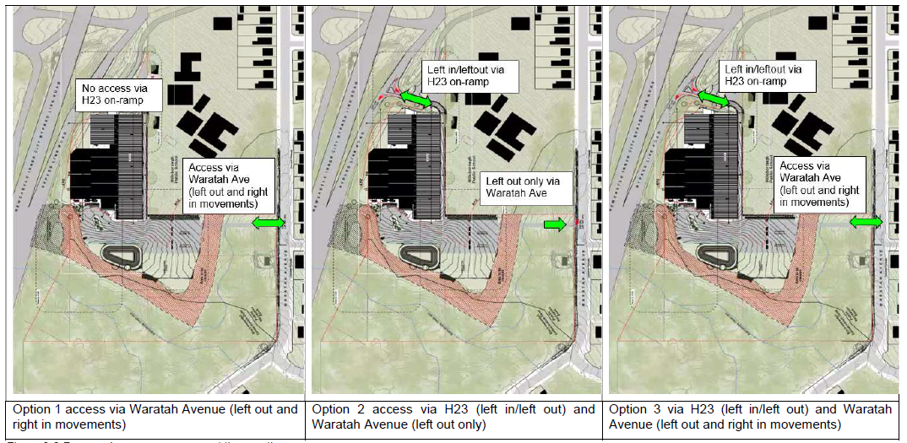
Figure 2: Traffic modelling options
The modelling found existing capacity constraints within the state road network, particularly at the NICB/Hillsborough Road intersection (bow-tie roundabout), and noted westbound traffic flows on Hillsborough Road are critical and would be impacted by the development depending on access options.
The modelling examines both vehicle queue lengths and intersection level of service (LoS). The report recommends option 1 and option 3 as the preferred access options.
TfNSW favoured option 1 as it has the least impact on the state road network. This option removes the conflicting traffic movements at the bow-tie roundabout that disrupt the westbound traffic flows on Hillsborough Road and increase queue length.
Council acknowledges the existing capacity constraints during the afternoon peak period but does not favour directing all traffic associated with the development onto the local road network due to the impact on the amenity of local residents. As such, Council favours option 3 as having multiple access and egress options allows traffic associated with the development to disperse into the road network and not concentrate traffic impacts in one area. Further, there is only a minor variation (between 4 and 9 seconds) between Options 1 and 3 in relation to average delays at the modelled intersections.
To address the state network constraints during the afternoon peak arising from the conflicting turning movements at the bow-tie roundabout, the development can be conditioned to prohibit access to the site from the NICB on-ramp between 4 pm and 6 pm on weekdays. During these times, the following arrangements will apply:
- access will be from Waratah Avenue only
- ingress from the NICB on-ramp will be prohibited and egress onto the NICB on-ramp will be permitted.
The traffic impact assessment submitted identifies how this will be implemented during operation of the facility including measures such as gates preventing access, signage on all approaches to the stadium identifying access restrictions, member awareness packages, social media bulletins, and the like. It is considered where these measures are implemented effectively, the safety of the road network will not be affected by implementing option 3 rather than option 1. Conditions of consent can be imposed to achieve this outcome.
The majority of patrons accessing the site will be repeat users on a weekly basis (particularly during peak times) and will become accustomed to the applicable access arrangements. If a vehicle does try to enter the site via the NICB whilst this access is not operational, there is adequate space within the access road to turn around and enter safely back onto the NICB. This would allow vehicles to access the development via Warners Bay Road and EK Avenue without a significant time delay or impact on the road network.
TfNSW also raised a number of other matters in addition to the access arrangements to the site, as detailed below:
- Hillsborough Road parking lane capacity as turning lane
Investigations were requested into the capacity of the existing parking lane on Hillsborough Road to be an extended left turn lane. Council’s Traffic Engineer has reviewed the traffic modelling study prepared by TfNSW and confirmed the increased length of the turning lane does not demonstrate any improvement to the operation of the road network. As a result, this outcome will not be pursued and the parking lane will remain as is.
- Encroachments on pedestrian ramps and signal infrastructure from bus turning manoeuvres at the Hillsborough Road – Waratah Avenue.
Council’s Traffic Engineer has reviewed the development and identified sufficient area is available within the existing road reserve to enable this outcome to be achieved. Detailed design of the intersection works required for the construction certificate will address the minor encroachments identified.
- No parking will be permitted on the NICB on-ramp.
The provision of “No Stopping” signage is proposed as a condition of consent.
- No pedestrian or cyclist access should come from the NICB.
Existing pedestrian infrastructure will direct pedestrians to the Waratah Avenue access. Wayfinding signage can also be provided and can be included as a condition of consent.
- Recommended provision of a shared pathway from the Waratah Avenue access to Hillsborough Road.
An existing pedestrian footpath exists along both the western and eastern sides of Waratah Avenue with a marked pedestrian crossing. The provision of a shared pathway is not considered warranted.
The development provides internal pedestrian pathways to provide access and direct pedestrians to the existing Waratah Avenue infrastructure.
- Bus access/egress shall be from Waratah Avenue only.
In earlier correspondence, TfNSW raised concern with buses exiting the site onto the NICB on-ramp as they were unlikely to be able to build up to the required speed to merge into bypass traffic. Entry of buses into the site was not voiced as a concern. The NICB on-ramp contains an existing turning lane to access the site. It is not considered necessary or reasonable to restrict bus access to the site from the NICB. A condition can be included requiring all bus egress to be via Waratah Avenue.
- TfNSW requires access through the site for TfNSW staff or contractors to maintain the sediment basin located within the NICB road reserve.
The applicant has indicated their willingness to allow access to the site. A right of carriageway should be registered over the property to formalise this arrangement. This can be resolved through a condition of consent.
- All works on roads under the care and control of TfNSW will require the applicant to enter into a WAD. Works under the WAD shall be completed before the issue of an occupation certificate. A condition of consent will ensure this outcome.
- Channelised right turn (CHR) treatment to be provided on Waratah Avenue
Council’s Traffic Engineer reviewed the development and identified this treatment is not required as an alternate access is available from the NICB on-ramp, and the impacts of the treatment to the existing Hillsborough Public School ‘kiss and ride’ area that runs along the Waratah Ave frontage of the school.
Instead, ‘No Stopping’ signage can be installed on the eastern side of Waratah Avenue to facilitate the passing of vehicles turning right into the site. This would result in the loss of five on-street parking spaces and will need to be considered by the Traffic Facilities and Road Safety Committee. This outcome can be implemented through conditions of consent.
The latest revision of the development was not referred to TfNSW given the development is of a lower event capacity (from 4000 seats to 2500 seats), and the normal weekday operational comments were well understood and considered by Council.
Consideration has been given to the legislative thresholds of the Transport and Infrastructure SEPP and it is considered the development can operate, and be managed to ensure the efficient and ongoing operation of the NICB and local road network as detailed above. Further, considerations to the provisions of the SEPP identify the following:
- The development provides practicable and safe vehicular access from a road other than the NICB, a classified road. For the vehicle access which connects to the NICB, the access has been designed to support safe and efficient vehicle, and bus movements.
- The volume of vehicles using the classified road to gain access to the land will be restricted and controlled during peak times to ensure the efficient and ongoing operation of the NICB can occur.
- Safe and effective pedestrian movement can be achieved through the use of existing infrastructure.
Events and tournaments will be managed under an event management plan (EMP) for events with more than 1100 patrons. A traffic event management plan was submitted with the application outlining the following:
- Three major events of more than 800 patrons per annum
These events typically occur on a weekend. Transportation is expected to be via chartered bus services facilitated as part of the event, or shuttle buses from identified public transport facilities including bus stops and railway stations. The exact location of these has not been secured, although several have been nominated in the event management plan, and would be subject to the owner’s approval for each event. It is anticipated patrons can book shuttle services as part of their ticket purchase.
Event parking controls will be implemented along Hillsborough Road, Waratah Avenue, and other local streets subject to discussion and approval by Council or TfNSW. Access to the on-site parking will primarily be restricted to those directly associated with the event including players, officials, caterers, first aid staff, and teams arriving in buses. However, depending on the size of the event, provision for including on-site parking for patrons will be made available in some instances. Parking would be restricted only to the number of car parking spaces available, and revert to public transport and shuttle bus once all spaces have been booked.
An event drop-off/pick-up/rideshare/taxi zone will be implemented temporarily along Waratah Avenue to provide for the drop-off and pick-up of patrons.
Variable message boards and marshals will be implemented temporarily on the approaching roads to direct non-parking ticket holders to the park and ride sites for the event and warn other road users of upcoming traffic congestion before the event or after the event. A Traffic Control Plan (TCP) will be implemented for each event.
All pedestrian access to the site will be via Waratah Avenue, similar to the normal weekday operations.
- School gala type events
These events typically occur mid-week and during school hours (i.e. 9am-3pm). For these events, buses are utilised to transport students to and from the venue, with students on-site for the duration of the event.
The EMP will be conditioned to specifically address these types of events to manage the allocation of parking and access to the site, which will restrict the number of vehicles entering and exiting the site.
TfNSW provided comments that traffic EMP lacked sufficient detail (i.e. number of events, methods of transportation). A more detailed EMP was subsequently submitted providing further clarity on the expected number of major events and proposed measures to transport patrons to and from the site. Given the small number of major events the detailed EMP is appropriate to manage the events described.
The remaining items to be considered for events will be captured in a detailed EMP. A detailed EMP has not been submitted. The requirement for submission of this document is proposed as a condition of consent, with no events to be held until the document has been reviewed and approved by Council and TfNSW. The detailed EMP also is proposed to be conditioned to be reviewed and updated as more events are held and feedback from the event informs the subsequent plans.
5.2 Building height
The application proposes a maximum building height of 13.7m. The portion of the site where the building form is located is subject to a maximum building height of 8.5m. The application proposes a 5.2m or 61 percent variation to the maximum building height, relating to the upper roof pitch of the main stadium building only. A portion of the playing courts’ roof also exceeds the height limit but to a lesser extent, up to 11m or 29 percent variation.
Accordingly, a clause 4.6 written variation was submitted with the application outlining the development standard is considered unreasonable and the development displays sufficient environmental planning grounds to warrant contravention of the development standard. Specifically:
- The proposal seeks to provide a high-quality, purpose-built recreation facility that displays strong adherence to industry standards and design constraints.
The design of the new building is well-considered and appropriate in terms of its architectural form.
Building orientation and form, roof form, materials and finishes, and placement integrate the building with the site and will present a high quality/high amenity and cohesive outcome for the site and surrounds and provides a high-quality urban form as required by the objectives of clause 4.3.
- When viewed from adjoining areas, the new building will not present an overbearing bulk and scale as the site is substantially separated from and screened by vegetation from view from the adjoining residential area east of the site, and the development provides a quality appearance to the adjoining school.
- The development does not introduce visual privacy impacts to adjoining lands, particularly the adjoining school.
- The development does not have adverse overshadowing impacts, particularly concerning vegetation to be retained on the site, and the adjoining school.
- The height of the main stadium building is attributed to tiered seating, and BCA and ergonomic standard requirements, in conjunction with necessitating compliance with international standards for basketball court dimensions and ceiling heights.
- No reasonable amendment could be undertaken to achieve the building height standard, whilst achieving the functionality requirements of the facility.
The proposed variation is considered acceptable for the reasons detailed above. The building provides a building height that facilitates the function of the development, whilst not having adverse impacts on surrounding lands and users. The building is of a high-quality urban form and is consistent with the objectives of the height of building LEP provisions.
The clause 4.6 variation submitted with the application adequately demonstrates compliance with the development standard is unreasonable and unnecessary in the circumstance of this case and that there are sufficient environmental planning grounds to justify contravening the development standard for the proposed development on this site.
The development will result in an improved planning outcome, when compared to a development that would comply with the 8.5m building height. A development complying with the 8.5m building height would not result in a functional or operational building able to accommodate the development. The development provides a better outcome for and from the development by allowing greater flexibility in this particular circumstance.
The applicant’s written request has adequately addressed the matters required to be demonstrated by clause 4.6. The development is in the public interest as it is consistent with the objectives of the particular standard and the objectives for development within the zone in which the development will be carried out.
The applicant’s clause 4.6 variation meets the tests described for such a variation and is therefore supported.
5.3 Biodiversity and tree removal
The application proposes to remove and modify 0.30 hectares of native vegetation within the eastern portion of the site to enable the bridged Waratah Avenue access to be provided. Vegetation to be removed is identified as Blackbutt – Turpentine – Sydney Blue Gum.
This clearing triggers the Biodiversity Offset Scheme (BOS) due to clearing thresholds being exceeded. Consequently, the development will generate a credit obligation of six ecosystem credits for impacts on the identified vegetation.
The BDAR identified occurrences of Tetratheca juncea and observed a Powerful Owl (Ninox strenua) within the study area. However, no occurrence of Tetratheca juncea or suitable habitat occurs within the proposed footprint for this species. Similarly, habitat for the Powerful owl (Ninox strenua) is restricted to riparian habitats. Although the proposed works require a creek crossing, no suitable breeding habitat (such as large hollow-bearing trees) were identified within the riparian habitats across the site. To ameliorate the lack of breeding habitat available the installation of Forest Owl nest boxes within the study area is recommended as a condition of consent.
A BDAR was submitted with the application outlining the impacts of the proposed development, including vegetation removal, and concludes the development is acceptable and meets the provisions of the relevant biodiversity legislation. The BDAR recommends a vegetation management plan (VMP) be implemented for retained vegetated lands on site; this is proposed as a condition of consent.
Council’s Ecologist is supportive of the development noting the development has avoided and minimised impacts to important habitat features, including riparian habitats, connectivity features, and foraging resources for a range of fauna species. The extent of impacts to native vegetation has been appropriately assessed in accordance with the Biodiversity Assessment Method (BAM) 2020.
An arborist report was submitted which assessed 23 trees and recommends the removal of five trees (eucalypt, camphor laurel, tallowwood, and native daphane) located adjacent to the boundary on the adjoining school site. This removal is due to earthworks and retaining required along the boundary. Owner’s consent has been provided from the Department of Education for this removal.
Several other trees were identified as requiring sensitive construction methods. Conditions are proposed to ensure appropriate techniques are implemented ensuring retention.
5.4 Acoustic impact
An acoustic assessment, including revisions, was submitted with the application. The report identifies the development can achieve required acoustic outcomes. Specifically,
- Building elements to be implemented to ensure acoustic criteria is achieved to residential receivers in Waratah Avenue (such as, use of certain materials in roof and wall construction).
- Ongoing management controls implemented to ensure the development does not create noise nuisance to residential receivers in Waratah Avenue.
- Noise associated with traffic movements complies with the daytime criteria (7am-10pm) at residential receivers along Waratah Avenue.
- The function room is not intended to have amplified music. A condition of consent is proposed to limit the use of the space in this manner.
- Acoustic barriers provided to mechanical plant.
- Development of a noise management plan, for both normal operations and special events.
The operating hours of the development will be restricted to 7am to 10pm only. It is noted the Statement of Environmental Effects states hours of operation as 6am to 11pm, however, this has not been assessed acoustically and is not supported. Conditions of consent are proposed to achieve this outcome.
Council’s Environmental Management Officer is supportive of the development. The officer recommends installation of noise limiting equipment as part of the development to ensure exceedances do not occur in the first instance and to reduce ongoing reliance on non-engineered noise control strategies. Conditions are proposed to this effect.
5.5 Bushfire
A bushfire report, including revisions, was submitted with the application. The report identifies the development achieves required bushfire protection measures and outcomes. Specifically,
- Development constructed to BAL 12.5 construction.
- A performance solution is provided for analysis of APZ to the south and requirement to achieve radiant heat protection outcomes (i.e. no more than 10kW/m²). This results in a 72m APZ, and the revised architectural plans confirms the entire building is located outside of the APZ.
- Ongoing management of APZs.
- Access complies with bushfire requirements.
- Water and utility services are available to the site, or incorporated within the site (i.e. water tanks, fire pump, etc).
- Future landscaping and fencing within the site to comply with bushfire requirements.
- Preparation of a bushfire emergency management and evacuation plan.
NSW RFS is supportive of the development, including performance solution, and provided recommended conditions of consent which support the above recommendations.
It is acknowledged earlier iterations of the development proposed an APZ within the C2 zoned land. The revised site layout has removed the APZ from the C2 zoned land, all APZs are contained within the RE1 zone which is largely clear of vegetation.
- CONCLUSION AND RECOMMENDATION
This development application has been considered in accordance with the requirements of the EP&A Act and the Regulations as outlined in this report.
Following a thorough assessment of the relevant planning controls, issues raised in submissions, and the key issues identified in this report, it is considered the application can be supported.
The application is recommended for approval subject to a deferred commencement determination. The draft conditions of consent are attached to this report at Attachment A.

